**DSU DEV HACK**

HASH

The Automated Sanitization Revolution!



UV-C Light Disinfection

Disinfectant Sprayers

HEPA Air Filtration

Electrostatic Surface Sanitization

**Automatic Train Compartment Sanitization System**

**Automatic Train Compartment Sanitization System**

* UV-C Light Disinfection: Activated when compartments are empty to kill bacteria and viruses
* Disinfectant Sprayers: Automatically sprays non-toxic disinfectant on surfaces.
* HEPA Air Filtration: Continuously cleans the air of harmful particles during travel.
* Electrostatic Surface Sanitization: Coats surfaces with disinfectant to cover high-touch areas.



**Working Model:**

1. **Poor Air Detection:**



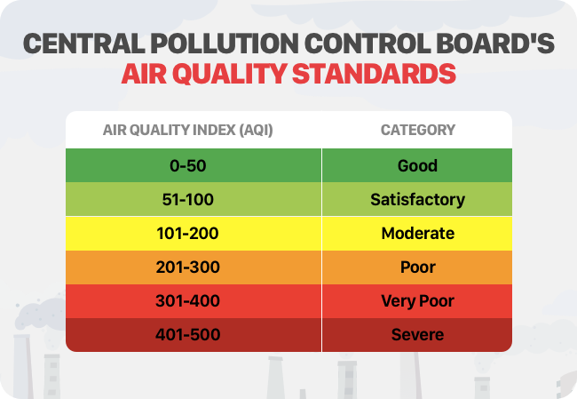

**Block Diagram:**

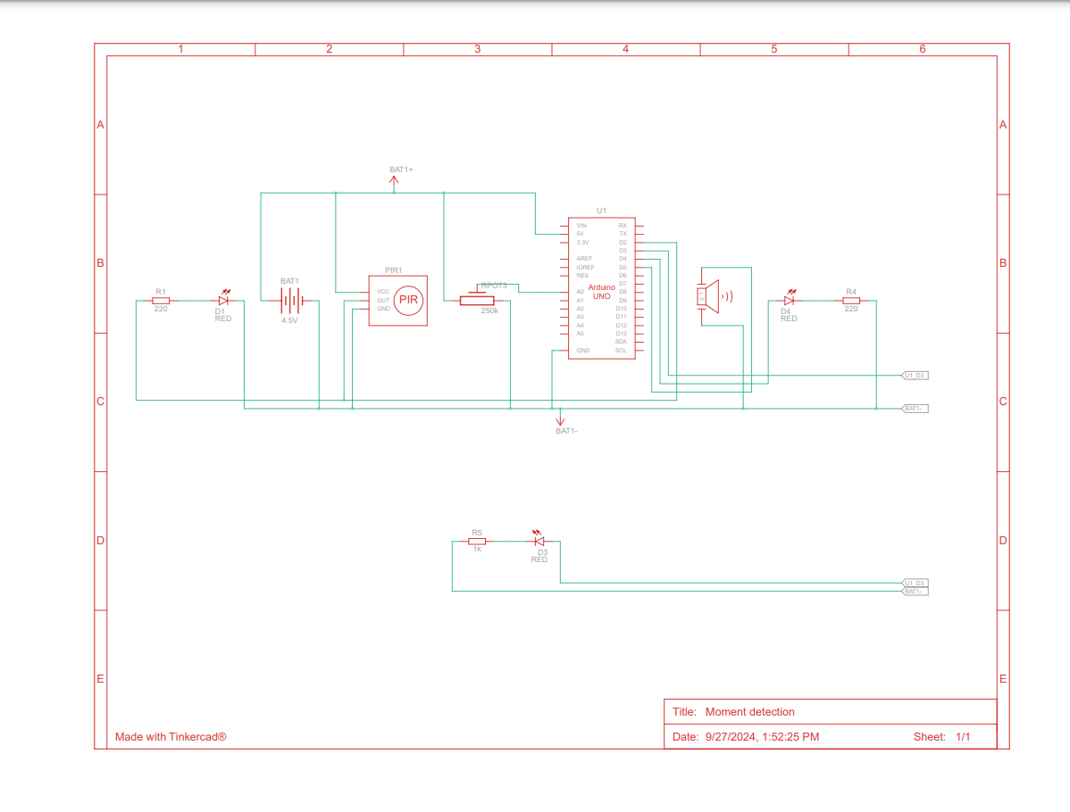

**Components Used:**



**Prototype:**

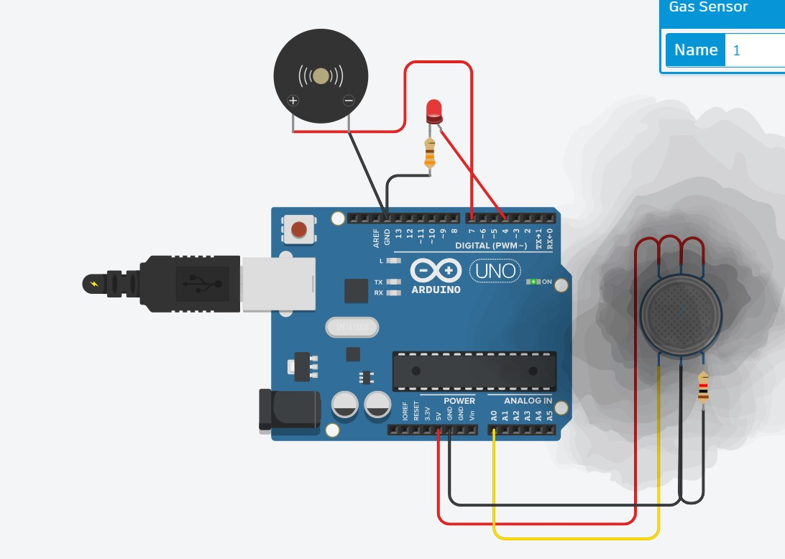

1. **Moment Detection:**

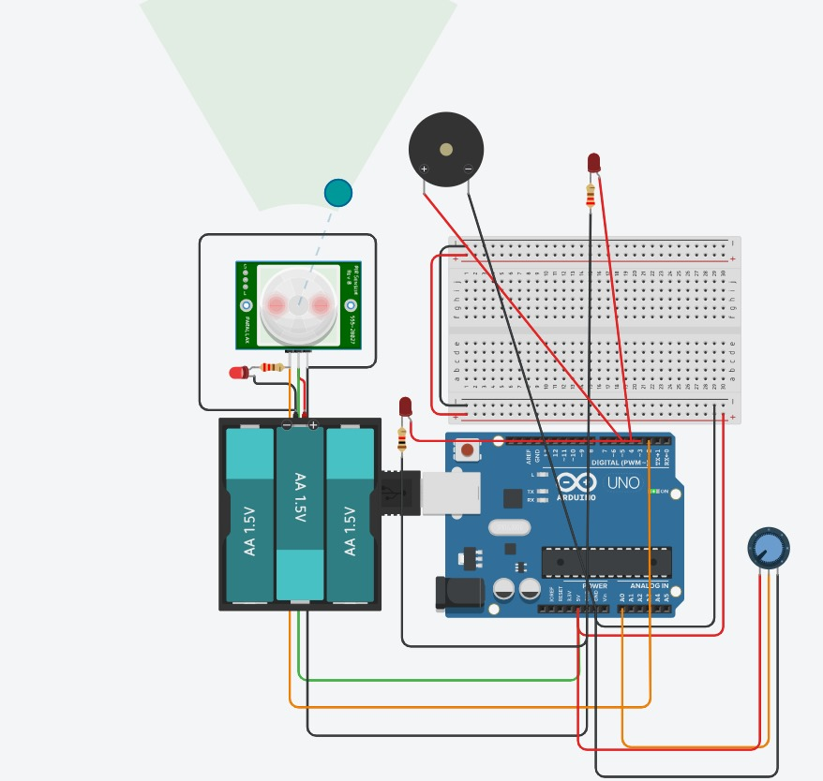

**Block Diagram:**

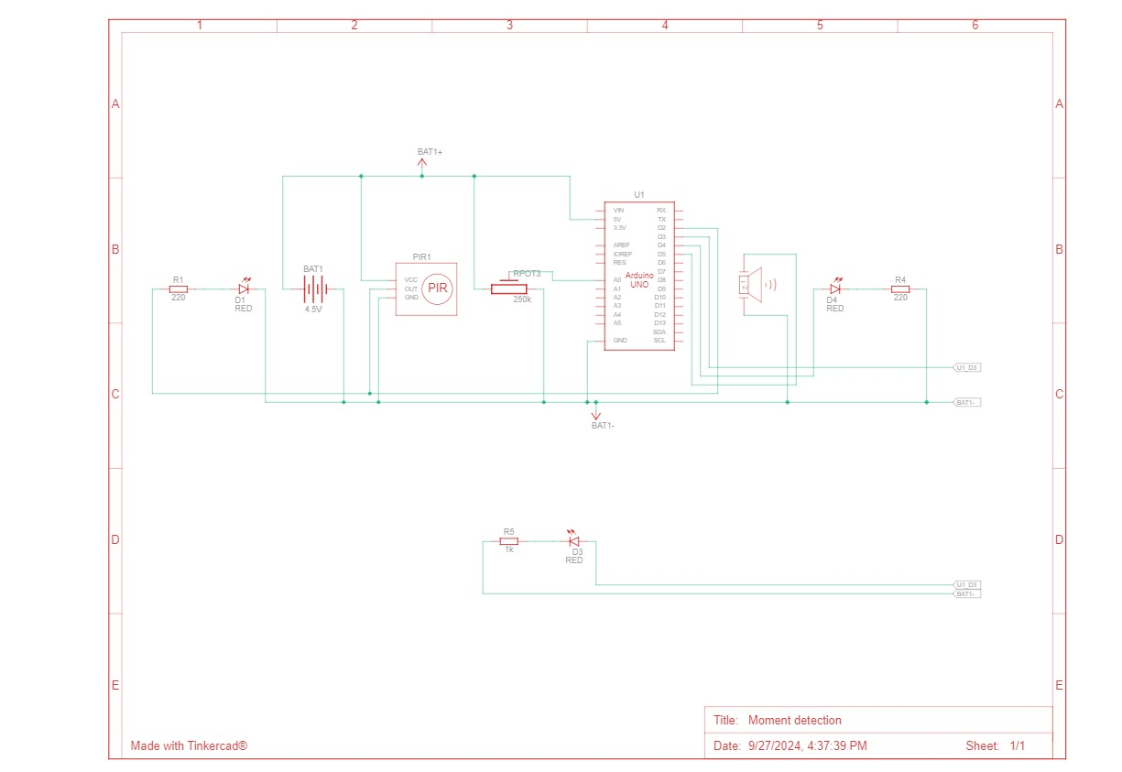

**Components Used:**

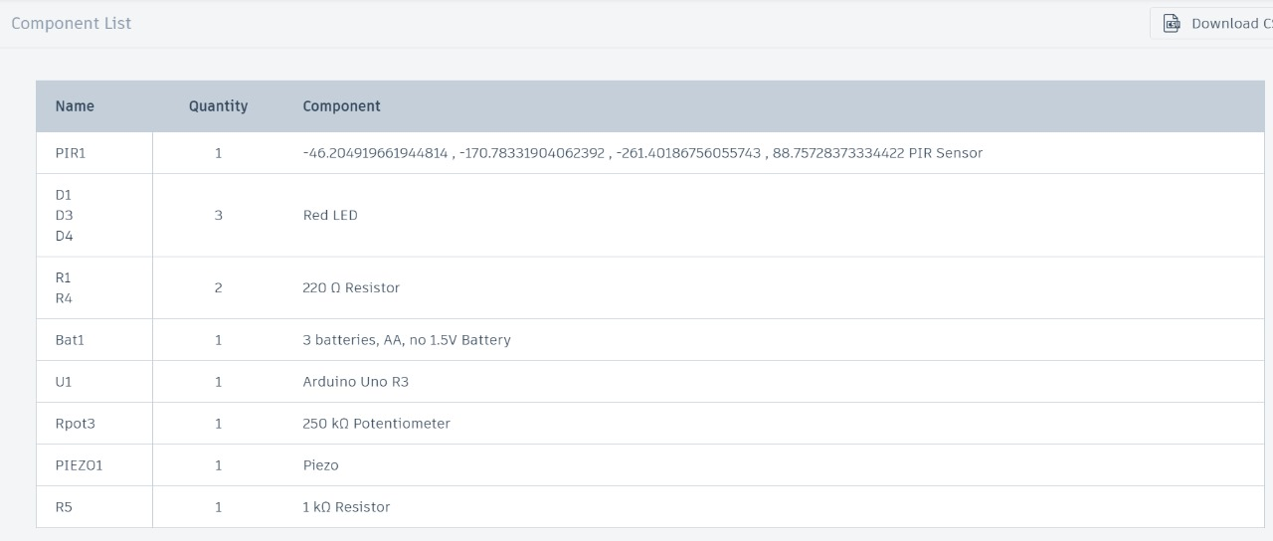

**3.UV-C Light Disinfection:**



**Block Diagram:**



**Components Used:**



**Conclusion:**

The development of the **automatic train sanitization system** represents a significant step towards enhancing public health and safety in public transportation. By integrating advanced sensors, real-time monitoring, and automated sanitization mechanisms such as UV lights and disinfectant sprays, the system ensures that hygiene standards are maintained consistently and effectively. This innovation minimizes human intervention and enables a cleaner environment for passengers, particularly in high-risk areas where pathogen spread is a concern.

The project demonstrates the feasibility and necessity of automating hygiene protocols in densely populated spaces like trains. With scalable technology and adaptable design, the system can be deployed in various transportation networks, contributing to safer travel experiences in the post-pandemic world. Future enhancements could include integrating AI for real-time decision-making and expanding the system's capabilities to address other environmental factors.

The paves the way for smarter, more responsive public transportation solutions, reflecting the growing importance of automation in promoting public health.